**BOOKSTORE DATABASE MANAGEMENT**

A PROJECT REPORT SUBMITTED TO

**THE NATIONAL INSTITUTE OF ENGINEERING**

**MYSURU-570 008**

(An Autonomous College)



In partial fulfillment for the award of degree for

**Bachelor of Engineering**

**in**

**Computer Science & Engineering**

Submitted by

**VEERESH (4NI14CS113)**

**VIKAS M (4NI14CS116)**

**YASHWANTH E (4NI14CS123)**

Under the Guidance of

**MJ YOGESH**

**RANI S**

**DEPARTMENT OF COMPUTER SCIENCE AND ENGINEERING**

**THE NATIONAL INSTITUTE OF ENGINEERING**

Mysore-570 008

2016-2017

**THE NATIONAL INSTITUTE OF ENGINEERING**

(An Autonomous Institution, affiliated to VTU)

**DEPARTMENT OF COMPUTER SCIENCE AND ENGINEERING**



**CERTIFICATE**

Certificate that the project work titled: “**BOOKSTORE DATABASE MANAGEMENT** ” is a work carried out by **VEERESH** bearing **4NI14CS113, VIKAS M** bearing **4NI14CS116, YASHWANTH E** bearing **4NI14CS123** in partial fulfillment for the project prescribed by **National Institute of Engineering,** Autonomous Institution under Vishveshwaraya Technological University, Belgaum, for the FIFTH semester B.E Computer Science & Engineering. It is certified that all corrections/suggestion indicated for Internal Assessment have been incorporated. The project Report has been approved as it satisfies the academic requirements in respect of the project work prescribed.

**Signature of the internal Guide Signature of the internal Guide**

**(**MJ Yogesh**) (**Rani S)

**Signature of the HOD**

(Dr. HD Phaneendra)

**ACKNOWLEDGEMENTS**

I would like to take this opportunity to express my profound gratitude to all those people who have directly or indirectly involved in the completion of the project. I thank everyone who encouraged me in every possible way.

I would like to thank our Principal **Dr. G.L. SHEKAR** for letting us to be part of this prestigious institution and letting us to explore our abilities to the fullest.

I would like to extend my sincere gratitude to our **H.O.D Dr. HD Phaneendra** for being a source of inspiration and instilling an enthusiastic spirit in me throughout the process of project making.

I wish to express my heartfelt gratitude towards my project guides **MJ Yogesh, Rani S** for their constant support and guidance, valuable knowledge and experience.

Veeresh

Vikas M

Yashwanth E

**CONTENTS**

**ABSTRACT**.........................................................................................................Page 01

1. **INTRODUCTION**

**2.1** Database Management System................................................................Page 02 **2.2** Objective of the Project...........................................................................Page 03

1. **RELATED WORK AND SURVEY**

**3.1** Existing System...........................................................................................Page 04

**3.2** Proposed System.........................................................................................Page 04

1. **SYSTEM ANALYSIS**....................................................................................Page 05

Basic Requirements...........................................................................................Page 06

1. **SYSTEM DESIGN**.........................................................................................Page 07
2. **SYSTEM IMPLEMETATIONS**..............................................................Page 10

**06. SIMPLE TEST CASES**..........................................................................Page 12

**07. SCREENSHOTS**......................................................................................Page 14

**08. ADVANTAGES & LIMITATIONS**...................................................Page18

**09. FUTURE ENHANCEMENTS AND RECOMMENDATIONS**.......Page 20

**10. CONCLUSION**.................................................................................................Page 21

**REFERRENCE**...........................................................................................Page 21

**ABSTRACT**

The main purpose of this system is to give easier access to the information on books with simple user interface and basic computer knowledge.

It eases the task of a bookstore administrator who maintains the books information in the store. The sole purpose of this system is to keep a record on the information of book such as author, ISBN, publisher , price etc.

This system is very simple to use for every customer to retrieve data on the book required by the customer. The information is just a click away after they enter the specified field.

This Database contains attributes such as Author , ISBN , Price , Publisher etc.

**CHAPTER - 1**

**INTRODUCTION**

Databases and database technology have a major impact on the growing use of computers. It is fair to say that databases play a critical role in almost all areas where computers age used, including business, electronic commerce, engineering. Medicine, genetics. Labs in colleges, library science. A database is a collection of related data.

**DATABASE MANAGEMENT SYSTEM**

A database management system (DBMS) is a collection of programs that enables users to create and maintain a database. The DBMS is a general purpose software system that facilitates the processes of defining, constructing, manipulating, and sharing databases among various users and applications.

The database is the process of storing the data on some storage medium that is controlled by the DBMS. Manipulating a database includes functions such as querying the database to retrieve, insert and delete specific data, updating the database to reflect changes in the database and generating reports from the data.

Some important functions provided by the DBMS include protecting the database and maintaining it over a long period of time. Protection includes system protection against hardware or software malfunction (or crashes).

Security protection against unauthorized or malicious access. A typical large database may have a life cycle of many years, so the DBMS must be able to maintain the database system by allowing the system to evolve as requirements change over time. It is not absolutely necessary to use general purpose DBMS software to implement a computerized database. We could write our own set of programs to create and maintain the database, in effect creating our own special-purpose DBMS software.

**OBJECTIVE**

The very sole purpose is to design a data base management software that insert, retrieve, delete etc also it retrieves further info on the selected book through Wikipedia(via internet).

Making use of this software has several advantages when compared to ledger and very few or none disadvantages .This digitally developed software can hold multiple domains, attributes, relations.

This being a main objective is very much cared and implemented in the software.

In this modern era when everything is online our project provides user all the necessary info in most simple and convenient way possible. This being one among main objective in our software.

Considering the very fact that many bookstores and libraries(in educational and public sectors) does not contain this type of software which is very useful in such a way that it reduces manual work to some extent. It also helps us by organizing data in a specified manner which is useful for the user.

This can be most effective in small scale bookstores and libraries.

Hence using this software over comes the above glitches and serves its very own purpose.

**CHAPTER - 2**

**RELATED WORK AND SURVEY**

1. **Existing** **System :** We surveyed about the existing system and found out that many small scale bookstores doesn't have system that gives us the information regarding the books like author, publisher, Genre of book, Price etc. Every time a customer walks inside the bookstore and asks whether a book by a name is available here, the worker (some cases the Owner itself ) has to go through the shelves to find out information on book, or has to go through some old ledgers for this information, which is time consuming and manual work is needed.
2. **Proposed System :** In order to overcome this problem , we have tried to create a system that holds the information on books which can be accessed with one Tap by the bookstore administrator as well as the customer. This system helps both customer as well as administrator to find information on required book just by typing the Name or Author or ISBN sitting/standing in same place without much of manual work. Also it is digitized so the accuracy of data is very high and application is much reliable and compact than the ledgers.

**Survey :** We went through some of the very famous Database Management Textbooks like "The Database Book : Principles and Practice Using MySQL" by Narain Gehani and also “Fundamentals of Database Management System” by Elmarsi and Navathe.

We also went through some advanced and expensive systems that are used in some popular websites like goodreads.com.

**CHAPTER-3**

**SYSTEM ANALYSIS**

There are mainly 2 persons here :

1. **Administrator**
2. **Customer**

**Functionalities:**

* **Admin:**
* Insert
* Delete
* Retrieve
* Update
* **Customer:**
* Retrieve

1. Based on Title
2. Based on ISBN
3. Based on Author name
4. Based on Language
5. Based on Genre

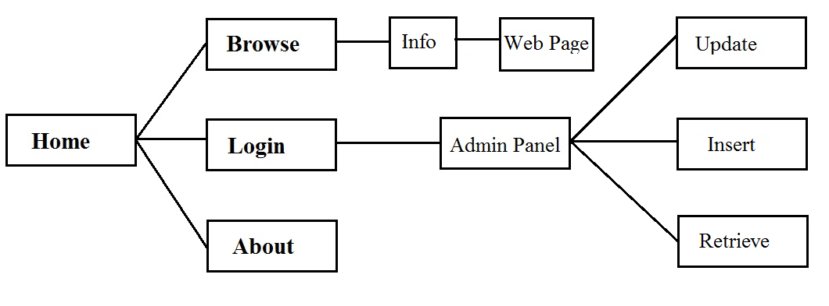

**BASIC REQUIREMENTS**

Software requirements :

Operating System : Windows 8 and higher

Programming Language :C# .NET, MySQL

Drivers :MySQL for Visual Studio, MySQL Connector

Tools :Visual Studio 2015, MS Office

**Hardware Requirements** :

* Minimum :

1. Processor : Intel Pentium 4, 2GHz
2. Memory : 512 MB of RAM
3. HDD : 500MB

* Recommended :

1. Processor : Intel i5, 3GHz
2. Memory : 2 GB of RAM
3. HDD : 5 GB

**CHAPTER - 4**

**SYSTEM DESIGN**

**UI Design :** The entire user interface is designed using C# .NET with Microsoft Visual Studio 2015.

We use reference "MySql.Data.MySqlClient" to link the database to the user interface. We use following :

MySqlConnection - to establish connection to MySQL server.

MySqlCommand - to query in the database.

MySqlDataReader - reads all the data from query generated , so that we can show the changes made in user interface.

We also use several built-in tools like :

TextBox : to enter the text.

MessageBox : to show a dialogue box with messages specified by programmer to help the user with invalid inputs etc.

RadioButtons , CheckBox : these are used for if/switch constructs.

Button : every button defines a function which takes in data and shows outputs on the interface.

ListView : this shows a listed view of data , we use it to show the results from query generated.

Label : very similar to textbox but this does not take inputs , it just shows what the programmer has assigned it for. Ex : when a book is inserted , this is used to display a message "book inserted" in the UI.



* In the first window , we have created a textbox with a search button to search for books with fields such as 'Title', 'ISBN', 'Author'.
* If we move to 'Browse' window from here, which acts like a advanced search option. Here one can search for info on books with attributes like 'Author', 'Language', 'Genre', 'Publisher'. This also shows us results from internet to buy the book online from the site 'Amazon.com'.
* Another window to move from 'Home' window is 'Admin' page.

This page requires login , thus it first shows a login page, on successful login we are moved to Admin page.

* In 'Admin' page we have Insert , Retrieve, Delete options. Also a window to Update the information of book based on Title or ISBN.
* One more button in 'Home' is 'About' which is 'About' box of software. This shows some related info on project itself.
* There are 'Exit' buttons in windows which helps us to get back to 'Home' window or to Quit the application depending on the placement of 'Exit' button.

**ER MODEL**

The ER model defines the conceptual view of a database. It works around real-world entities and the associations among them. At view level, the ER model is considered a good option for designing databases.

**DATA AND FUNCTIONAL REQUIREMENTS:**

The Basic data and functional requirements of our data base include the following:-

1. The Entire Database is Organized into 3 entities namely:-
2. **Books**
3. **Authors**
4. **Login**

These Functional and Data requirements from the user is very necessary for the successful execution of the database. The designer can ensure that the database meets all the aspects of the database.

We now define the entity types for the Database based on the requirements. According to the requirements listed, we can identify 3 entity types :

* The entity type **Books** has following attributes
* ISBN - **Primary Key**
* Title
* Authors
* Publishers
* Price
* Language
* Genre

**Books**

* The entity type **Author** has attributes
* sname - **Primary Key**
* fname
* lname
* fullname
* Country

**Author**

* An entity type **Login** with attributes
* Username
* Password

**Login**

**CHAPTER - 5**

**SYSTEM IMPLEMENTATION**

* The Complete Description of “books” table.

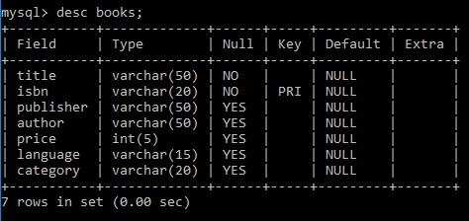

* The Complete Description of “authors” table.

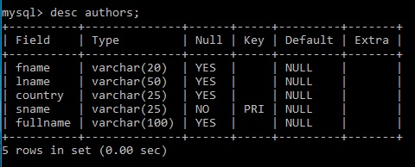

* The Complete Description of “Login” table.

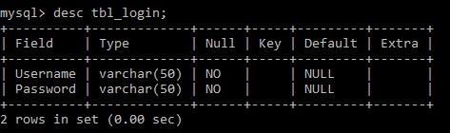

**Search :** The Search technique we used here is the default query used in MySQL ie 'select' query.

We use the same select query to search the specific values using 'where' clause.

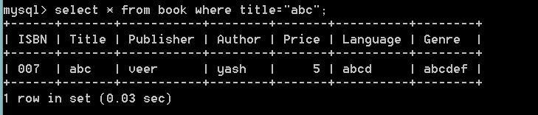

**Update:** The updating process is completed using query 'Update' from MySQL.

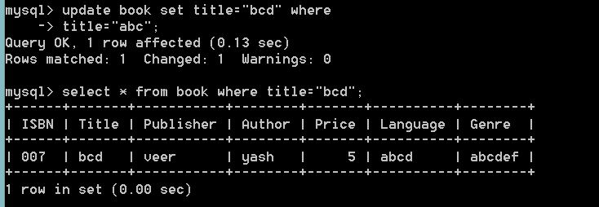

**CHAPTER - 6**

**SIMPLE TEST CASES**

We have included 3 different scenarios.

* **Book Search :**

|  |  |  |
| --- | --- | --- |
| Test Case | Input | Result |
| First | Valid Input | Perfect result with all details |
| Second | Invalid Input | NO result, message showing "book not found" |

* **Login :**

|  |  |  |  |
| --- | --- | --- | --- |
| Test Case | Username | Password | Result |
| First | Empty | Empty | "Both Fields are Mandatory" |
| Second | Valid | Invalid | Invalid Login |
| Third | Invalid | Valid | Invalid Login |
| Fourth | Invalid | Invalid | Invalid Login |
| Fifth | Valid | Valid | Valid Login |

* **Insert :**

|  |  |  |
| --- | --- | --- |
| Test Case | Entries | Result |
| First | All Valid Entries | Insertion Successful |
| Second | Invalid entry to one or more fields | Insertion Not Successful |

**CHAPTER - 8**

**SCREENSHOTS**

**HOME Page**



**Browse Page**

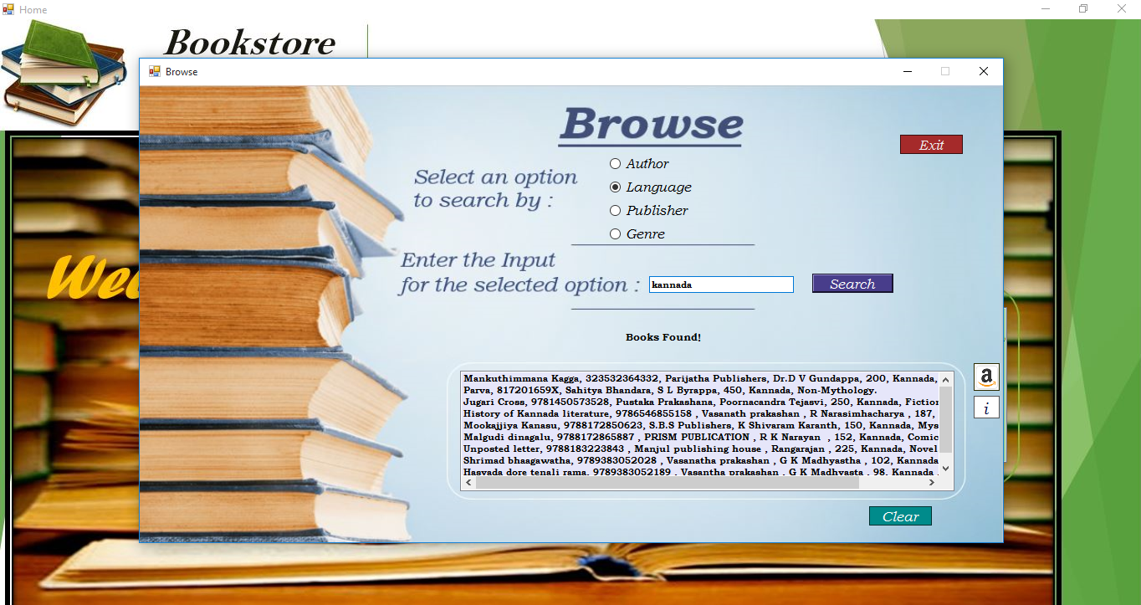

**Author search**

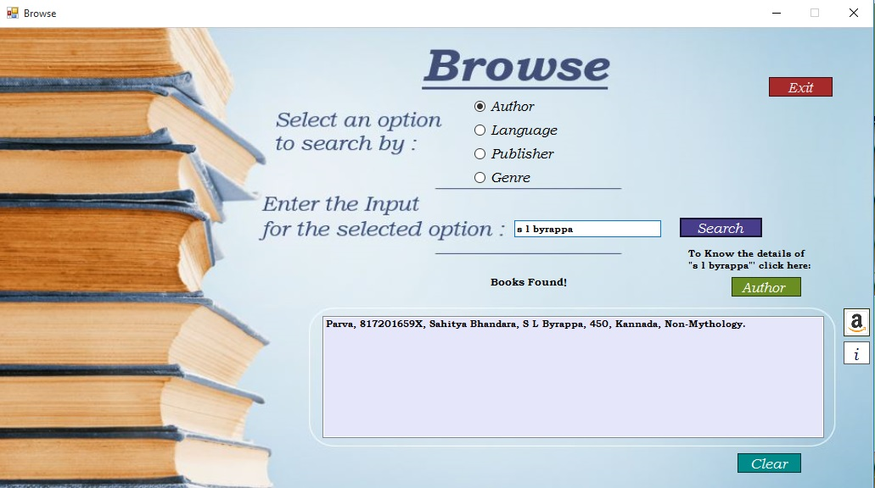

**Author info**

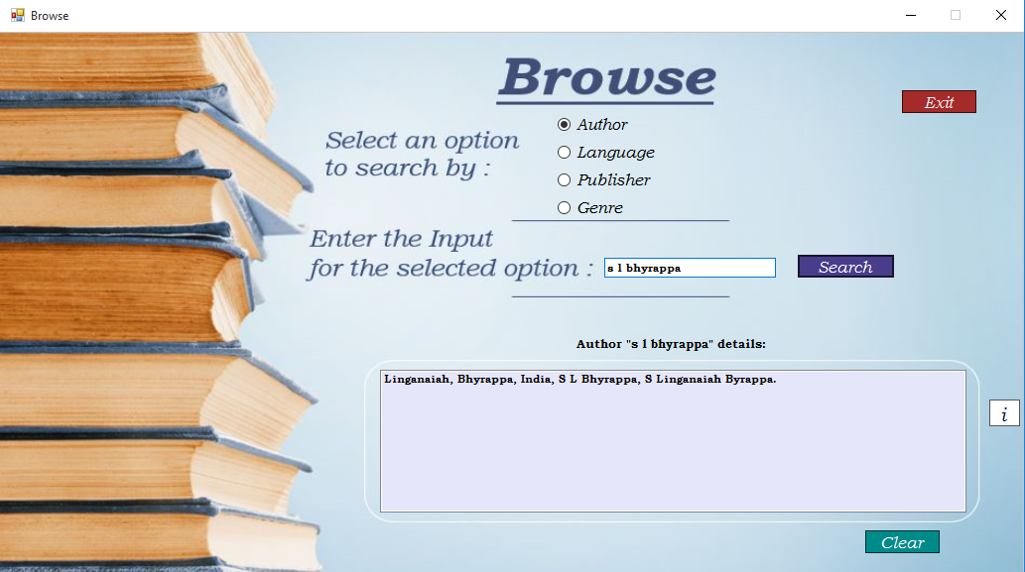

**Amazon Page**



**Login Page**

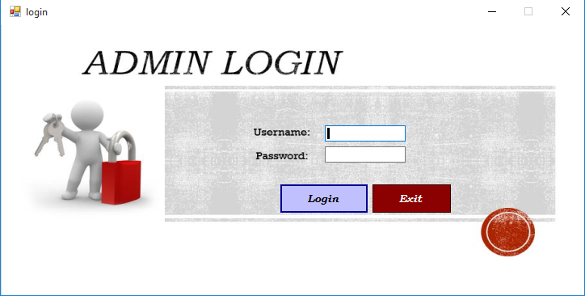

**Admin Page**

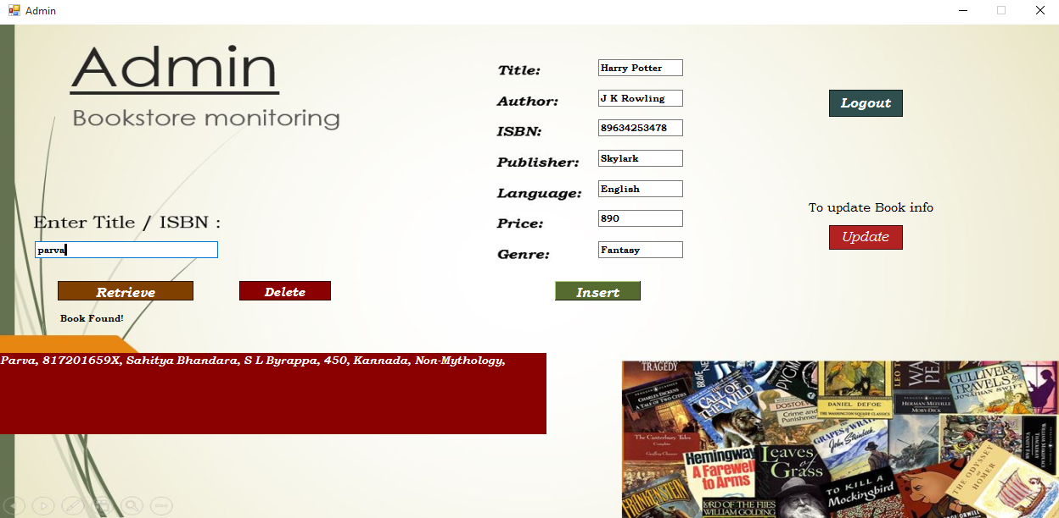

**Update Page (1)**



**Update Page (2)**



**CHAPTER - 8**

**APPLICATIONS**

**9.1 ADVANTAGES :**

* User Interface is very Simple.
* UI has almost all features including Insert, Delete and Update.
* Provides access for both customer and the Administrator.
* In case of data loss, it can be recovered easily as it is stored digitally.
* Data can be easily manipulated.
* Application is also portable, thus data can be accessed from any system that is connected to the specific server.
* It provides a platform which can be improved along with the use.
* It is more user friendly in nature.
* It has fast or quick operation.

**9.2 LIMITATIONS :**

* Requirement of uninterrupted power source.
* Requirement of expensive hardware when compared to inexpensive paper and pen.
* Switching on to the computer and logging in to the software is time consuming when compared with personal knowledge.
* A person often known as technician who knows to debug and troubleshoot the software is required.
* The size of the database increases day-by-day, increasing the load on the database back up and data maintenance activity.

**CHAPTER - 9**

**FUTURE ENHANCEMENTS**

This project can be further improved by:

* Images of the books can be included.
* Barcode / QR code tag can be used as ID’s if necessary.
* It can be expanded to multiple platforms like Android / iOS.
* An option to attach PDF's can be added, which can be used for demo

(Not included here because most of them are ©Copyrighted.)

**CHAPTER - 10**

**CONCLUSION**

The very fact or the reason that the regular old school type hard ledger book has many Disadvantages is the reason why things are made digital so as to overcome these drawbacks. Even though digital system might have few unwanted glitches they are quite negligible when compared to the old technique.

Errors occur in many ways which needs to be handled. Errors such as human errors, loss of data such as records and information about the components might be lost or hampered are taken care of here.

Using this tool in many universities creates a universal platform which is a boon. Thus by using this software we are able to encounter problems faced in using regular ledger book and also simplify the day to day activities performed in a library or bookstore.

**REFERENCES**

1. https:// wikipedia.org/
2. https://stackoverflow.com/
3. https://www.visualstudio.com/
4. https://www.tutorialspoint.com/csharp/
5. "The Database Book : Principles and Practice Using MySQL" by Narain Gehani, Universities Press Private Limited 2008.
6. “Fundamentals of Database Management System” by Elmarsi and Navathe, Addison-Wesley, 5th Edition 2007.